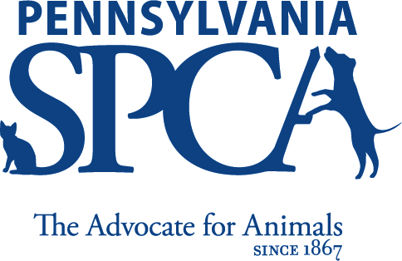

Donor Privacy Policy
The Pennsylvania SPCA is committed to respecting the privacy of its donors. The organization has developed this Donor Privacy Policy to assure donors that their personal information will not be sold or rented to, or exchanged with, any third party.

No Sale, Rent, or Exchange of Personal Information. The Pennsylvania SPCA does not sell, rent, or exchange donors’ personal information. The Pennsylvania SPCA uses donors’ personal information for its internal purposes only, to advance the charitable mission and activities of the Pennsylvania SPCA.

Publication of Names. On occasion, the Pennsylvania SPCA lists the names of its donors on its website or other publications. Donors may contact the Pennsylvania SPCA to request that they not be included in such lists.

Removing Donors’ Names from Pennsylvania SPCA’s Mailing List. It is the Pennsylvania SPCA’s desire not to send unwanted mail to its donors. Donors may contact the Pennsylvania SPCA if they wish to be removed from its mailing list.

Contacting Pennsylvania SPCA. Donors who have comments or questions about the Pennsylvania SPCA’s Donor Privacy Policy may contact Allison Hough, Executive Director of Development, at 267.463.2321 or development@pspca.org.

Updated: November 8, 2018

